**Draw Your Path**

**Genre – Action / Adventure**

Gameplay

**The big picture**

In this VR game, the player is able to draw objects that can then be interacted with in the game environment.

Challenges in the game include fast drawing, choosing the right items to draw for different scenarios.

for example - when enemies are coming towards you, you're going to need to draw a shield and a sword quickly before they get you to defeat them, and there could be also enemies that use long range weapons like arrows, so you'll need to draw for yourself some cover to avoid getting hit.

The game takes place in a map that has 5 areas.

in each area enemies will attack the player then after defeating them the player must find his way through doors, hallways, or gates to progress into the next area, and may need to draw specific objects to pass these pathways, sometimes after defeating the enemies player must solve puzzles in order to move on into the next area of the map towards the main goal which is retrieving the item that got lost in the alternate timeline.

for example - to open a door player must draw a hammer to break it to move on to the next area, if there's a rift between our area and the next area the player will have to draw a platform like a bridge to walk on to be able to cross the gap.

From the beginning of the game, the player will be provided with a list of all the drawings that they can make.

**Background to the Story –**

The story takes place in the far future in a time where everyone could get the most advanced technology easily unsupervised thanks to the corporations who just want to make profit and sell to whoever they can no matter how dangerous the products they sell.

**Story -**

after being asked to do some grocery shopping for your mother as soon as you get to the door of your house u realize you forgot to bring milk, now you being too scared to enter the house with a missing item and too lazy to go all the way back you decide to use a device to go back in time to the grocery store to get that milk, but something goes wrong – the device being sold by a greedy company who doesn’t bother checking it’s quality turns out to be faulty then you find yourself teleporting to a different timeline trying to find a way back home.

Your mission now becomes twofold: find a way back home and retrieve the grocery shopping bag that scattered in the alternate timeline to avoid your mother's wrath.

At the beginning of your journey, you come across a mysterious tool which gives you the ability to draw a set of things and brings whatever you draw from that set to life, and this tool will help you get through the whole journey.

So, the question is - will you be able to make it back home and save the day, or will you be stuck in the alternate timeline forever?

**Scenes -**

1 scene for the game menu, 1 scene which is only a cutscene for the story when we get teleported from our home to an alternate timeline, 1 scene for the map we play in.

**First scene – The Game menu :**

Game starts with main menu; player has 2 options –

1 – Start : to start the game, when player clicks it using the ray interactor, he’ll go into the second scene.

2 – About : to see what the game is all about.

**Second scene – Story Cutscene :**

Player will get to see the story of the game through a cutscene then will go into the third scene.

**Third scene –**

The scene where we play and get in the action as detailed in the walkthrough, the scene starts with tutorial. After tutorial player will begin his path to the main objective which is to retrieve the shopping bag. After grabbing the grocery shopping bag player will go into the first scene.

**Mechanics**

- the player can move ,turn, dodge , block, and attack using the drawing mechanic.

**Drawing mechanic –**

The tools to use the drawing mechanic is of course a marker and a canvas which look like this :

**Draw Canvas Marker**

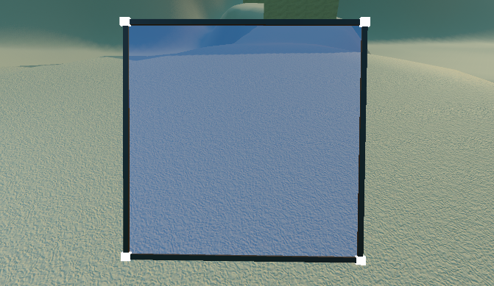

The player will be provided with a set of things that he can draw, the player can take a look at the set anytime he wants throughout the game by pressing the button.

**The set of drawings that the player will see in game**

When you activate the drawing ability, the hand which activated the ability will turn into a marker and the other hand will turn into a transparent drawing canvas ,u can move both by moving your hands around ,you will do that in order to draw the object you want .

- The more accurate the player draws a certain item the more effective it becomes for example – after drawing a weapon like a sword if it’s really accurate to the blueprint of the sword that is in the set of things that you can draw, you’ll get a sword that will do a lot of damage and will have more durability, of course if you didn’t like what you created maybe because it was not drawn very accurately to the blueprints you could always drop that item and try again to draw better one.

- Items you draw have a durability bar meaning that they will break after a certain amount of use.

**An example -**

Here we can see right before the player confirms that he finished drawing, you will be able to see through the canvas -

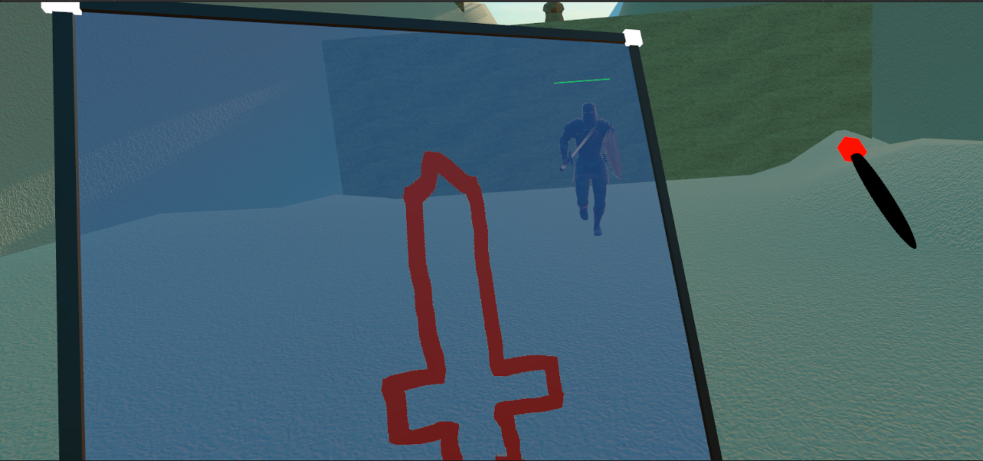

Here is a picture after confirming the drawing and the player gets to use the sword he drew; the player got a regular sword as we can see as it spawns with a text specifying what type of item he got –

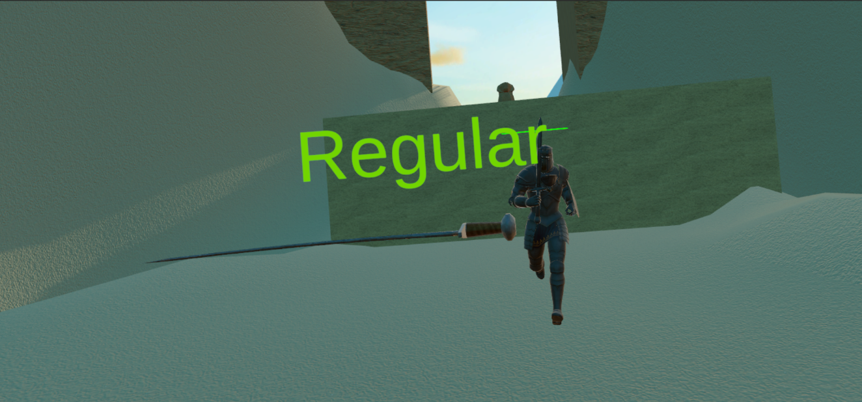

-Blocking the enemy attack will be done by using a shield that the player must draw, upon blocking the enemy attack the player won’t take any damage instead the shield will be damaged and loses some durability

- Player can draw cover for himself for defence, and it’s not only shields to be held by his hand it could also be walls that he can draw so he can take cover from ranged attacks or it could be a strategy to outsmart the enemy for example – draw walls to your right, left and behind in order to leave no choice for the enemy but to come only from one direction and make it easier for you to take them out.

- **Draw spells** **-** player can also draw things other than objects to interact with in the game, there are spells for defence for example –a spell to regenerate a small amount of health. There are spells for attacking, for example - shoot a fireball from the tip of the marker.

**Walkthrough**

After the player press start in the game menu a cut scene will start playing after the cut scene the player will spawn and in front of him will be a wall with instructions on it to explain what each button does and the things he can draw and there will be a tutorial on how to use the drawing mechanic after that the player will walk into the 1st area (training area) where he will be first faced with a dummy that just stands there without moving ready to be attacked by the player, after killing this dummy u will be faced with another dummy but this dummy tries to block the player attacks, after killing it u will be faced with an actual enemy that will attack, after dealing with it the tutorial will be completed and the player will go through a tunnel to the second area where he will be faced with 2 melee enemies that he should kill and then complete a puzzle to pass to the second part of this area, there u will be faced with another 4 melee enemies again killing them will allow you to move into the next puzzle to path to the 3rd area which looks like an abandoned town there u will be faced with 3 archers and 3 melee enemies u should deal with them while collecting 6 strength potions that will give you enough strength to be able to pass the next area by breaking a huge gate with a hammer ,after slamming the door and pathing through it the player will reach the 4th area which is a long path were in it he will face few melee enemies along the way the path will have several walls in it which blocks the player path , he will have to destroy them using a hammer to continue moving forward after reaching the end of the path the player will be faced by a single melee enemy blocking the tunnel to the 5th area dealing with him and entering the 5th and last area which is a path way under the pyramid the player will be faced a few last enemies before reaching the end and collecting the grocery bag and completing the game .

**Controls**

Left joystick :- walk/move.

Right joystick :- turn left/right.

Hold A :- spawns a red marker in the right hand and a canvas in the left hand.

Hold B :- spawns a yellow marker in the right hand and a canvas in the left hand.

Hold X :- spawns a red marker in the left hand and a canvas in the right hand.

Hold Y :- spawns a yellow marker in the left hand and a canvas in the right hand.

click :- shows a menu of the things you can draw.

Hold left grasp :- grab items in left hand.

Hold right grasp :- grab items in right hand.

**Player**

- The Player has a finite health bar. In order to regenerate a portion of it, the player must use a healing spell.

- After dying the player respawns with full health bar and the enemy count will stay the same as it was before he died meaning that areas do not reset when a player dies.

- After completing an area , the player will have to go through a tunnel or a door to get to the next area, when he continues to the next area, he can choose to keep the items he had already drawn or throw them and draw new items

**Enemies**

We’ve seen previously some examples on what happens when entering an area, as soon as the player enters the new area the enemies will spawn some areas will have a second wave after the player deals with the first one.

There are 2 types of enemies that the player will encounter :

**First is a melee type –** a Paladin wearing a full armored set with a sword and shield, this type will have 3 moves in his arsenal :-

Sword attack :- a high attack, the enemy swings his sword forward to slice the player upper body .

Kick :- a low attack, the enemy will right kick the player to the lower body.

Block :- the enemy raises his shield in front of him trying to block the incoming attack from the player.

**Second is a ranged type –** an archer wearing a garment set with a bow and arrow, this type will have only one move which is shooting arrows.

Some areas will contain only one type of enemies, and some with have both types, the ranged enemies will mostly be placed in places that the player can’t reach so he will have to use a spell in order to deal with them.

Both Erica and Paladin will deal 10 damage to player.

**Architecture**

**Enemy code: -**

**1.Paladin: -**

Paladin is a melee enemy with a sword and shield this enemy contains 6 scripts: -

1.Paladin Combat: - this script controls Paladin attacking pattern and cooldowns.

2.Enemy Controller: - this script interacts with the Navigating component setting the range and the speed.

3.Paladin Script: - this is the script that controls paladin health, getting damaged, animations.

4.Paladin Sword: - this script checks if the sword collides with the player shield or body to deal damage and plays the audio.

5.Paladin Shield: - this script checks if paladin blocked the player attack preventing him from taking damage.

6.Kick: - checks if paladin kicked the player or the shield and deals damage and plays audio.

**2.Erika: -**

Erika is a ranged enemy with bow and arow that contains 4 scripts: -

1. Enemy Controller: - this script interacts with the Navigating component setting the range and the speed.

2. Erika Script: - this is the script that controls Erika health, getting damaged, animations.

3. Erika Combat: - this script controls Erika attacking pattern and cooldowns.

4. Arrow: - this script initiates the arrow shotting prosses it spawns the arrow and give it the force and direction needed to hit the player.

**Object management code:**

1. Management scripts for the (SwordManagement / ShieldManagement / HammerManagement / BridgeManagement / FireBallManagement / RegenerateHealth ):- these scripts all have the same concept , each one takes the drawing the player made and takes the highest and lowest X and Y coordinates In player’s drawing in order to know where to draw the object in the canvas, then we compare the drawing the algorithm made and the player’s drawing to check what the player drawn and at which accuracy it was drawn. These scripts also limit the number of objects you can draw for each type .

The way they compare the player drawing is by iterating on the pixels that the management script expects to have marked pixel one by one and checks if the player’s drawing also has pixels marked wherever the algorithms expects there to be a pixel marked. In the end it calculates the percentage of the matched pixels between the player’s drawing and the script drawing. If it’s below 40-50% the percentage the management script will return will be 0 indicating that the player’s drawing is not what the object management script expected.

2. Sword: - checks if the sword collides with enemies and their shields and deals damage and updates the durability and plays audios on impact.

3. Hammer: - checks if the hammer collides with enemies and their shields and deals damage and updates the durability and plays audios on impact.

4. Shield: - checks if Shield Blocked the Enemy attack if so, reduces durability and prevents player from taking damage.

5. Bridge: - controls bridge timer and changes the layer of the bridge to the appropriate layer.

6. Fireball: - controls fire ball dmg and velocity and direction.

**Drawing Mechanic code:**

1. Marker Spawn: - this script controls spawning the marker and the canvas whenever the player activates the ability.

2. Draw Canvas: - this script initiates the canvas and sets it size as a Vector2, also gives the canvas its texture, it also resets the pixels that were saved in the vector after the player finishes drawing and the comparison is done.

3. Save And Compare Drawing: - this script is in charge of taking the player’s drawing and sending it to the object management scripts with the highest/lowest Y and X coordinates.

after receiving the percentage of matching pixels from each management script it chooses the object with the highest percentage to spawn, this script also saves the drawing the player made and saves the drawings that our management scripts made as a “PNG” file for us the developers to check for testing out our drawing algorithms.

4. Draw - this script indicates when the tip of the marker is in touch with the drawing canvas and if so, it starts drawing on it. As the player draws the script actively updates the highest/lowest Y and X coordinates and sends them to the save and compare drawing script.

**Area Management Code: -**

Area Detector: - a script to detect if the player entered an area and if so, activates that area.

Area UI: - the is one area UI for each area and each script manages the hints and messages that pops up in that area, also it manages the enemy spawns and player respawn point.

Area Navigator: - checks which area is active to set it as the player spawning point.